# File permissions in Linux

## Project description

In this project we are going to see how Linux commands work on changing permissions of different directories and files. First, we are going to check on the actual permissions of the files (including hidden files), we are going to change them so in that way they can have the permissions they have to and finally we are going to change directory permissions. In this way we assure that the principle of least privilege it’s essential to keep this company secure.

## Check file and directory details

Here we check all the permissions that the directory of “projects” has and all the files that are part of the analysts site. We use ls -la to display permissions of the directory and hidden files.

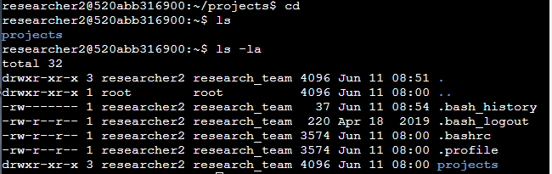

In this one, we move inside the directory of “projects” to know what permissions the files have from inside. We use the same command (ls -la) as in the previous activity just to check and display all files permissions (those which are hidden too).

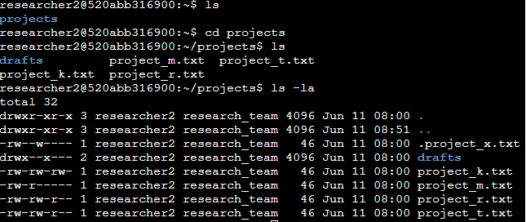

In both cases, we are able to see how using the command os ls -la just to display the permissions of files and hidden files, each file appears row by row with their own permissions.

## Describe the permissions string

The permission strings appear everytime we try to access to the display of permissions. For example, in the screenshot from above we see a lot of permission strings, we’ll choose this one:



The permission strings always are 10 characters long and they go in a specific order. First they declare if it’s a directory or not, then they specify which permission the user has, then the group and finally the others. For example: the *d*is for *directory* (in this case we are talking about the directory of projects), the next group of three characters tell us the *user* permissions (*rwx*) in the present case we can see that the user has *reading*, *writing* and *executing* permissions. In the next three characters it describes which permissions the *group* has (*r-x*), so we can see that the group can *read* and can *execute* it but they are not able to *write* anything. In the last three ones, we are going to see what permissions others have within this directory, looking at the string we see the same characters as in the group string (*r-x*) that means that others can *read* and *execute* but not *write*.

## Change file permissions

We previously know that the organization does not allow *other* to have write access to any files so our job is to change the permissions using the command of *chmod*. In the file named project_k.txt the other user has write permission and that’s what we are going to change.

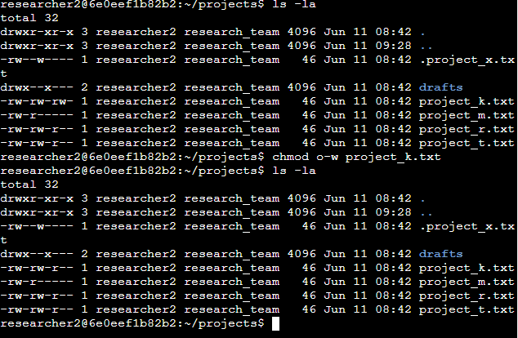

In order to change the permissions given to *other* I used the command of *chmod* which is used to change permissions on files and directories. Then I added two arguments: *o-w* because o means *other* and w means *write*, so in this argument I’m taking out the permission of *writing* of the *other* user. The second argument is where I want to make the change, whether it’s a file or a directory, in this case is the file *project_k.txt* .

## Change file permissions on a hidden file

Our task now is to change file permissions but on this occasion it's a hidden file. We know that this file has been archived, that's why it's hidden. The file shouldn’t have write permissions for anyone, but the user and the group should be able to read the file. Actually, the file has *read* permission for the *user* and *writing* permission for *user* and *other*.



In this moment, we are using the command of *chmod* to change file permissions on *.project_x.txt* file. To make this change, after the command of *chmod* we are going to put two arguments to do it everything at once: we are putting *chmod ug-w,g+r .project_x.txt, ug-w* stands for user and group removing from them the permission of writing, *g+r* stands for group and giving them the permission to read the file. Then we use *ls –la* command to check if our *chmod* command worked correctly.

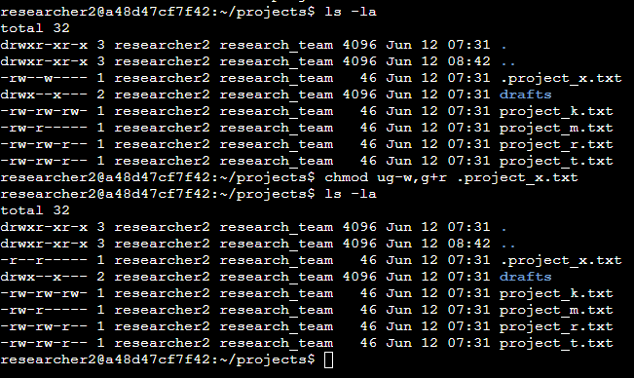

## Change directory permissions

In this part, we are going to check directory permissions. The files and directories in the projects directory belong to the *researcher2* user. Only *researcher2* should be allowed to access the drafts directory and its contents.



In this screenshot we see that the user (*researcher2*) has reading, writing and executing permissions using the command *ls –la*, but we also see that the group has the ability to execute this directory, so we are removing this permission from them.

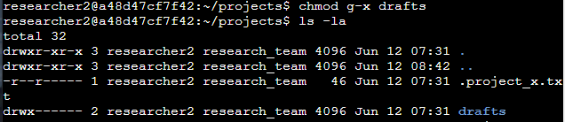

In this one, we used the previous used command of *chmod* to change permissions. We used the following full command: *chmod g-x drafts*. *Chmod* to change the permissions, *g-x* stands for group and removing the execution permission and *drafts* stands for the directory where we want to make changes.

## Summary

To sum up, we were tasked on ensuring users on this team were authorized with the appropriate permissions. I checked file and directory details and permissions, described the permissions string, changed file permissions including hidden files and changed directory permissions.